Hypertension (Objective Id, Ie, IIf)
- The definition of hypertension in infants from birth to the age of 12 months is not clearly defined. The following percentile graphs were obtained from a 2012 Pediatric Nephrology review on Hypertension in Infancy.
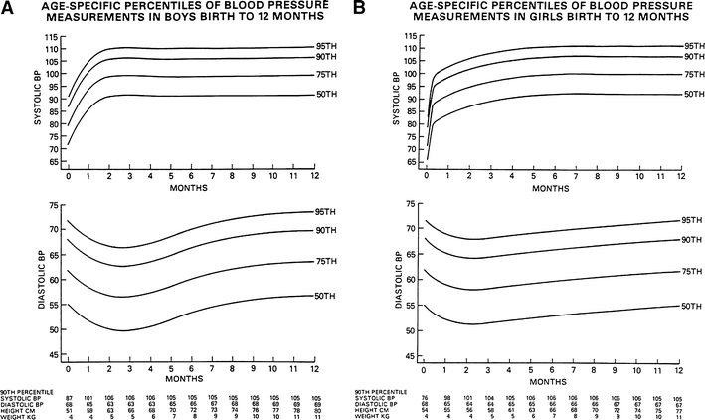
Dionna et al. 2012

- Hypertension in children ages 1-13 is defined per percentiles based on sex, age and height. The definition of normal blood pressure, elevated blood pressure, stage 1 hypertension, and stage 2 hypertension in children is outlined in the following table by the American Academy of Pediatrics 2017 and 2019 guidelines.
- Hypertension in children 13 and older is managed according to the American Heart Association 2017 guidelines.

For Children Aged 1–<13 y | For Children Aged ≥13 y
Normal BP: <90th percentile | Normal BP: <120/<80 mm Hg
Elevated BP: ≥90th percentile to <95th percentile or 120/80 mm Hg to <95th percentile (whichever is lower) | Elevated BP: 120/<80 to 129/<80 mm Hg
Stage 1 HTN: ≥95th percentile to <95th percentile + 12 mmHg, or 130/80 to 139/89 mm Hg (whichever is lower) | Stage 1 HTN: 130/80 to 139/89 mm Hg
Stage 2 HTN: ≥95th percentile + 12 mm Hg, or ≥140/90 mm Hg (whichever is lower) | Stage 2 HTN: ≥140/90 mm Hg
Flynn et al. 2017
- Blood pressure percentiles are determined based on age, height, and sex. Please see the following percentile tables for boys and girls.
- The evaluation of hypertension is outlined in the following table from the AAP 2017 guidelines. All patients with sustained hypertension will have a diagnostic evaluation that includes a urinalysis, chemistry panel, and lipid profile. All patients <6 years of age, with abnormal urinalysis, or abnormal renal function will also have a renal ultrasound. In patients with a BMI >95th %, the work up will additional including a hemoglobin A1c, AST/ ALT, and fasting lipid panel. Other diagnostic tests to consider if warranted by patient history include TSH, drug screen, polysomnogram for sleep apnea, or a CBC. For more information on the diagnostic evaluation of hypertension, please see the following summary of the 2017 AAP guidelines.
BP Category | BP Screening Schedule | Lifestyle Counseling (Weight and Nutrition) | Check Upper and Lower Extremity BP | ABPM | Diagnostic Evaluation | Initiate Treatment | Consider Subspecialty Referral
Normal | Annual | X | — | — | — | — | —
Elevated BP | Initial measurement | X | — | — | — | — | —
Elevated BP | Second measurement: repeat in 6 mo | X | X | — | — | — | —
Elevated BP | Third measurement: repeat in 6 mo | X | — | X | X | — | X
Stage 1 HTN | Initial measurement | X | — | — | — | — | —
Stage 1 HTN | Second measurement: repeat in 1–2 wk | X | X | — | — | — | —
Stage 1 HTN | Third measurement: repeat in 3 mo | X | — | X | X | X | X
Stage 2 HTN | Initial measurement | X | X | — | — | — | —
Stage 2 HTN | Second measurement: repeat, refer to specialty care within 1 wk | X | — | X | X | X | X
Flynn et al. 2017
- The treatment of hypertension consists of both lifestyle and pharmacologic interventions. Lifestyle interventions include a healthy, low-sodium diet (<2 grams/day) and proper sleep. Patients should be counseled on the dietary approaches to stop hypertension diet, also known as the DASH diet. Pharmacologic treatment in pediatrics consists of an ACE inhibitor, angiotensin receptor blocker, calcium channel blocker, or a thiazide diuretic. If a patient presents with a blood pressure reading >30 mmHg above the 95th percentile, >180/120, or symptomatic stage 2 hypertension (headache, visual changes, dizziness, or vomiting) please send the patient to the emergency room for immediate action (AAP 2017 Guidelines).

